Fruit Freshness Detection System based on ai model using gaz sensors – Project Workflow

Attachments :
-dataset csv files rotten, fresh , and their test files
-fruits_sensor_cleanmodelfinal. Google collab notebook
-fruit_model_int8.tflite tensorflowlite model
-H723_fruitssensormodel2 STM32 project
- https://youtube.com/shorts/GyLJFIVzdnI?si=toC3UCQQTHLMvcd2
1) Dataset Preparation
The first step was, of course, preparing a clean dataset to train the AI model.
The dataset was obtained from Kaggle.
This dataset is based on gas sensor readings collected over multiple days for different fruits. The recordings were performed over 5 days.
The original dataset used 9 gas sensors:
- MQ2-MQ3-MQ4-MQ5-MQ6-MQ7-MQ8-MQ9-MQ135
Each fruit had separate files for each day of measurement.
After conducting research, we found that most fruits release gases such as:
- Ethanol-Hydrogen sulfide-Alcohol compounds during the rotting process.
To simplify the system and reduce hardware complexity, we decided to keep only 5 gas sensors that were the most relevant:
- MQ2-MQ3-MQ5-MQ8-MQ135
Dataset Restructuring
The original dataset was organized into 5 classes per fruit:
- Day 1-Day 2-Day 3-Day 4-Day 5
To simplify the classification task, we converted it into a binary classification model:
Fresh Class
This class combines:
- Day 1
- Day 2
Rotten Class
This class combines:
- Day 3
- Day 4
- Day 5
This approach was chosen to remain on the safe side when determining whether a fruit is still consumable.
After restructuring the dataset:
- Two new CSV files were generated for training
- Two additional CSV files were created for testing purposes
2) AI Model Creation
After preparing the dataset, we moved on to building the AI model.
After multiple experiments and tests, we selected the model architecture implemented in a notebook developed using Google Colab (it can also be executed on Kaggle).
The neural network architecture consists of:
First Dense Layer
- 16 neurons
- ReLU activation function
This layer helps the model learn non-linear patterns.
Second Dense Layer
- 8 neurons
- ReLU activation function
Output Layer
- 1 neuron
- Sigmoid activation function
Since this is a binary classification model, the sigmoid function is used to generate binary outputs.
Model Optimization
After training:
- The model was quantized
- Converted from Keras format to TensorFlow Lite (TFLite)
This was done because STM32 deployment works better with:
- Quantized models
- TFLite-compatible formats
After conversion, the model was manually tested using custom inputs and produced very promising results.
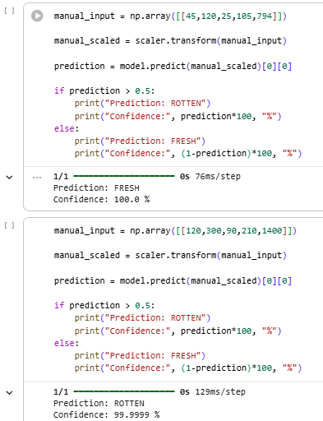

3) STM32 Deployment
The next step was deploying the model on an STM32 board.
For this project, we used the STM32H723 Nucleo Board.
Note: This board is not mandatory. Any board with performance similar to an STM32F4 Series or better should be able to run the model.
4) STM32 Project Configuration
First, a new STM32 project was created.
Then:
- USART3 was enabled in asynchronous mode
- Baud rate was set to 115200 bits/s
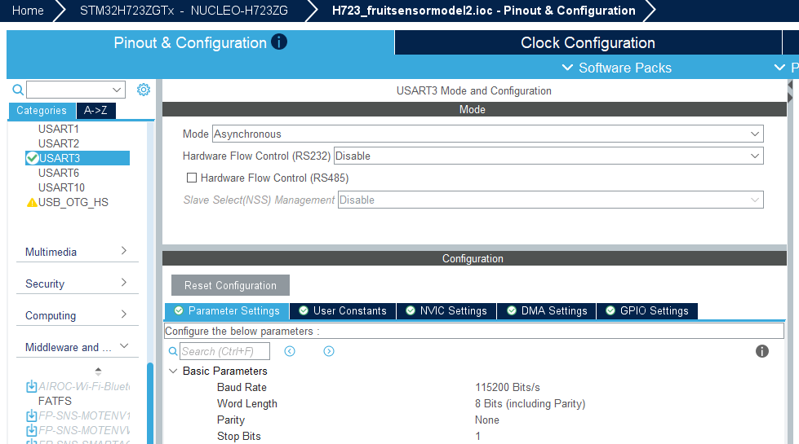
This allows prediction results to be displayed through a serial monitor.
Then I enabled ADC1 and IN2 IN3 IN4 IN5 IN6 channels in single ended mode
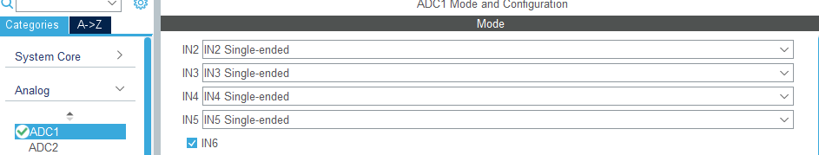
reduced resolution to 12-bits because I MQ gaz sensors are not premium products
enabled continuous conversion mode to changed number of conversion from 1 to 5
to be able to read from 5 channels
and configures ranks like this :
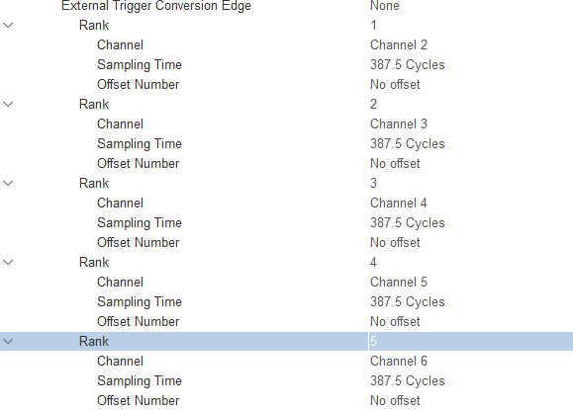
also enabled ADC1 NVIC
now in middleware and software packages I enabled X-cube-AI :
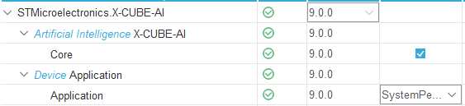
N.B : I didn’t try with STM32 cube AI studio but it gonna be an interesting method to see if it’s really an upgrade ort not from X-cube-Ai extension
now in X-cuibe-AI :
add your model select TFlite
analyze your model :
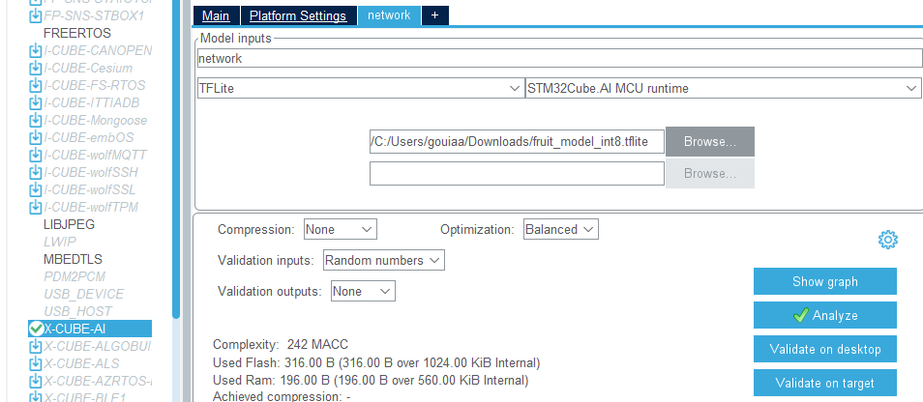
correct any issues if gotten in clock config
NB : its recommended to configure the SYSclk to run at maximum frequency due to AI heavy demands in my case I selected 275 because application is not heavy (particular case)
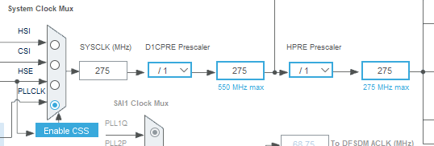
After configuration, the project was generated and opened in STM32CubeIDE.
open your project in STM32CubeIDE :
5) Model Testing
This section was divided into two parts.
Part 1: Testing the Model with Manual Inputs
The first step was testing the model using manually entered values.
This was done to verify that the model was correctly converted into C files before introducing real sensor data.
Using live sensor data at this stage would make debugging more difficult because sensor readings can be unstable and difficult to control.
To test manual inputs:
- Open app_x_cube_ai.c
- Comment LIVE_MODE
- Uncomment MANUAL_MODE

Then insert your desired test values in the appropriate input section.
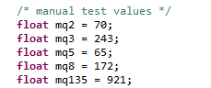
Flash the project and open serial monitor to read the results
example :
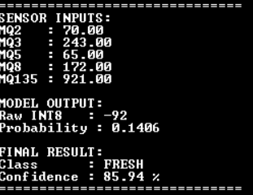
Part 2: Testing the Model with Live Gas Sensor Readings
This phase requires additional work.
Testing showed that MQ gas sensor readings vary significantly depending on the environment in which they operate.
Example
In the dataset: MQ2 reads around 50 for fresh fruits and can reach 250 when fruits become highly rotten
However, real-world tests showed that MQ2 can read around 1500 for fresh fruits and can reach 2000 for rotten fruits
This variation can be caused by several factors:
- ADC resolution differences
- Sensor condition
- Ambient environment
- Wiring issues
- Sensor calibration differences
6) Sensor Adaptation Strategy
To make the system more reliable for real-world usage, an adaptation mechanism was implemented.
Sensor Warm-Up
At startup:
- The system waits for 30 seconds
- This allows the gas sensors to heat up and stabilize
Baseline Calibration
After stabilization:
- The system collects 10 samples
- These samples are averaged to create a baseline value representing ambient air conditions
During this calibration period: No fruit should be placed near the sensors.
Input Adaptation
The system then:
- Adapts the baseline values to match dataset reference values
- Calculates the difference between baseline readings and fruit readings
- Uses these processed values as inputs for the AI model

Input Weight Fine-Tuning
Testing also showed that some sensors were more sensitive to certain rotten fruits than others.
To improve prediction accuracy: Additional fine-tuning adjustments were applied to input weights before sending data to the model.
7) Running Live Mode
To test the system with real sensor readings:
- Uncomment LIVE_MODE and Comment MANUAL_MODE
Connect the sensors as follows:
- MQ2 → PB0
- MQ3 → PA6
- MQ5 → PA3
- MQ8 → PB1
- MQ135 → PC0
Then:
- Run the project
- Open your serial monitor
- Set baud rate to 115200 bits/s
The system will then begin detecting whether the fruit is fresh or rotten based on real-time gas sensor readings.
example
